Assignment-2:

1.select count(*) as Deleted_Documentaries
-> from film
-> join film_category on film.film_id=film_category.film_id
-> join category on film_category.category_id = category.category_id
-> where category.name = "Documentary"
-> and film.special_features like "%Deleted Scenes%";

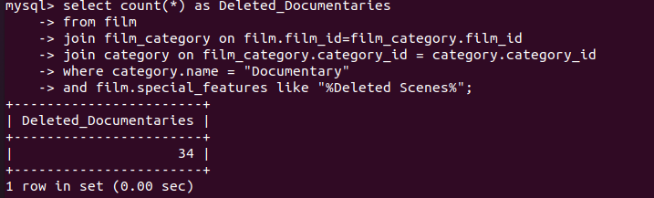

2.SELECT COUNT( rental.rental_id ) AS Rentals_Count
-> FROM rental
-> JOIN staff s1 ON rental.staff_id = s1.staff_id
-> JOIN store ON s1.store_id = store.store_id
-> JOIN staff s2 ON store.manager_staff_id = s2.staff_id
-> JOIN inventory ON rental.inventory_id = inventory.inventory_id
-> JOIN film ON inventory.film_id = film.film_id
-> JOIN film_category ON film.film_id = film_category.film_id
-> JOIN category ON film_category.category_id = category.category_id
-> WHERE s2.first_name = "Jon"
-> AND s2.last_name = "Stephens"
-> AND category.name = "Sci-Fi"
-> ORDER BY rental.rental_id;

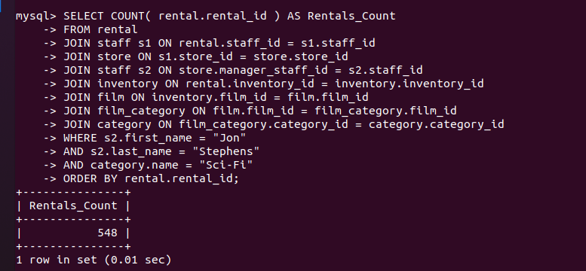
3.
select sum( payment.amount ) as Sales
-> from payment
-> join rental on payment.rental_id = rental.rental_id
-> join inventory on rental.inventory_id = inventory.inventory_id
-> join film on inventory.film_id = film.film_id
-> join film_category on film.film_id = film_category.film_id
-> join category on film_category.category_id = category.category_id
-> where category.name = "Animation";
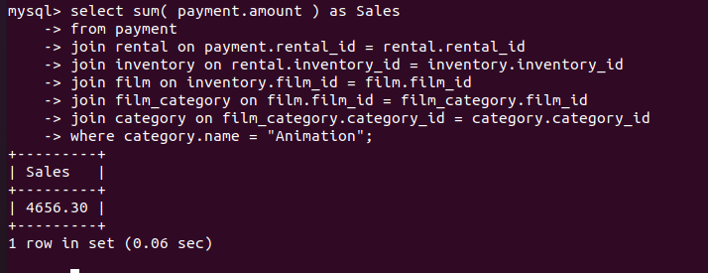

4.select category.name, count( * ) as rental
-> from rental
-> join inventory on rental.inventory_id = inventory.inventory_id
-> join film_category on inventory.film_id = film_category.film_id
-> join category on film_category.category_id = category.category_id
-> join customer on rental.customer_id = customer.customer_id
-> where customer.first_name = "PATRICIA"
-> and customer.last_name = "JOHNSON"
-> group by category.name
-> order by count( * ) desc
-> limit 3;
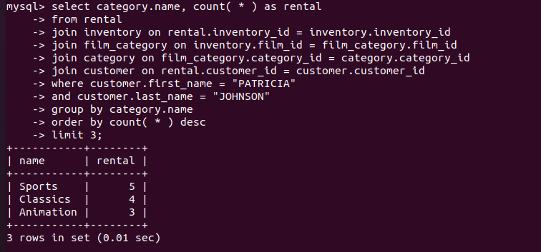

5.select count( * ) as Rented
-> from rental
-> join inventory on rental.inventory_id = inventory.inventory_id
-> join film on inventory.film_id = film.film_id
-> join customer on rental.customer_id = customer.customer_id
-> where customer.first_name = "SUSAN"
-> and customer.last_name = "WILSON"
-> and film.rating = "R";

